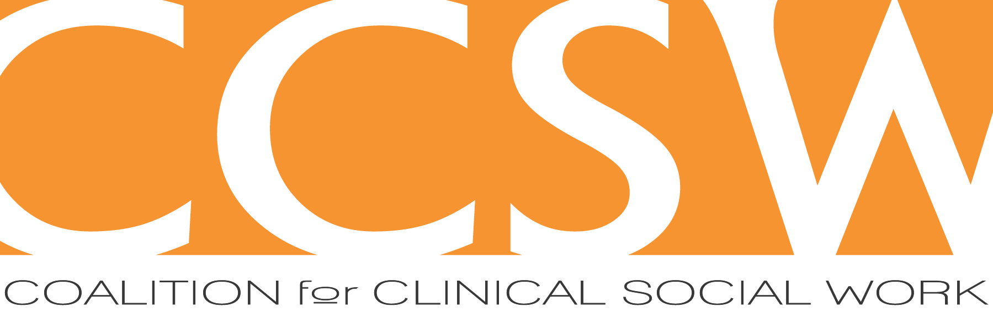

**CCSW Mentoring Program**

**Mentee Application**

Please answer the following questions and return this form by email to **ccswmentoring@gmail.com** by **July 31, 2024**. The information you provide on this form will be reviewed by the CCSW mentoring program committee and with your mentor should you be accepted into the program.

We consider specific interests related to clinical and professional development, geographic preferences, and day and time availability in our selection and matching process.

Unless you indicate otherwise, your email address will be added to our CCSW Google group as well so that you can be notified about our upcoming events.

1. Name:

2. Preferred Pronouns:

3. Contact information

* Phone number:
* Mailing address:
* Email address where you can be reached in the fall:

4. Degree Information

* Granting institution:
* Year:
* Type of degree:
* Licensure/credential:

5. Agency/type of practice (please describe the work that you do, including any specialization or area of particular interest):

6. What piqued your interest in having a mentor? How are you hoping to be helped by mentoring? What might you want to focus on with your mentor?

7. Tell us a little bit about your interest in psychodynamic thinking and/or its application to social work practice.

8. CCSW is a community of clinical social workers. What has led you to be interested in joining us?

9. All mentors volunteer their time, and most are also in full-time practice. Mentees are encouraged to be as flexible as possible in terms of their availability to meet with their mentors and must commit to attending each month’s meeting for the full academic year. Please list possible times and days of the week you would be available to meet monthly, in person and/or via video. A hybrid mix may also be an option.

|  |  |
| --- | --- |
| **Days of the Week** | Times |
|  |  |
|  |  |
|  |  |
|  |  |
|  |  |
|  |  |
|  |  |
|  |  |

10.  Anything else you’d like us to know about you or your interest in the mentoring program?

Thanks!